personal account overdraft

Test Number | Test Case Type | Description | Test Steps | Test Data | Expected Results | Actual Results | Status  (Pass/Fail)
1 | Functionality | personal account overdraft | Create a personal account with £100  opening balance  Attempt to withdraw£600  Check if transaction is allowed  Verify new balance | Opening Balance - £100  Withdrawal amount- £600  Overdraft limit -£500 | Transaction  Approved  New balance: -£500  (At overdraft  limit) Message  shows "Using  overdraft"3 | The system successfully processed the withdrawal of £600.0, resulting in a new balance of £-500.0 using the overdraft facility. | PASS
2 | Boundary | Withdraw  exactly at  overdraft  limit | Create personal account with £200  Withdraw £700  Verify transaction | Balance:  £200  Withdraw  £700  Available:  £700 | Transaction Approved  New balance: -£500 | The system approved the withdrawal of £700.0, bringing the account to exactly £-500.0, which is at the overdraft limit. | PASS
3 | Boundary | Attempt to  exceed  overdraft  limit | Create personal  Account with £100  Attempt to withdraw  £700  Verify rejection | Balance:  £100  Withdraw:  £700  Available:  £600 | Transaction Declined  Error: "Insufficient funds “Shows  available funds: £600 | The system rejected the withdrawal with the error message "Insufficient funds. Current balance: £100.0 | Available with overdraft: £600.0". | PASS
4 | Edge case | Zero balance to overdraft | Create account with £1  Withdraw £1  Withdraw £300 | Opening: £1  Withdrawals: £1, £300 | Both approved  Final balance: -£300 | The withdrawal of £300.0 was processed successfully, leaving the account with a negative balance of £-300.0 using overdraft. | PASS
5 | Multiple | Multiple overdraft withdrawals | Crete account with £500  Withdraw £600  Attempt to withdraw £500 | Balance: £500  Withdrawals: £600, £500 | First approved  Second declined | The first withdrawal of £600.0 was approved with a new balance of £-100.0, but the second withdrawal was rejected with "Error: Insufficient funds. Current balance: £-100.0 | Available with overdraft: £400.0". | PASS
6 | Recovery | Deposit to clear overdraft | Create account with  £100  Withdraw £400  Deposit £500 | Opening £100  Withdraw £400  Deposit £500 | Withdrawal Approved  Deposit Approved  Final balance £200 | The withdrawal of £400.0 resulted in a balance of £-300.0, and the subsequent deposit of £500.0 brought the final balance to £200.0. | PASS
7 | Display | Overdraft information display | Create account with £50  Attempt withdrawal of £500 | Balance £50  Withdrawal £500 | Show available funds £500  Warning about overdraft usage  Clear negative balance display | The system displayed "Error: Insufficient funds. Current balance: £50.0 | Available with overdraft: £450" when attempting the withdrawal. | PASS
8 | Maximum | Max overdraft usage | Create account with £0  Withdrawal £500 | Balance £0  Withdrawal  £500 | Transaction approved  Balance -£500 | The maximum overdraft was utilized when the withdrawal of £500.0 was approved, leaving the account balance at £-500.0. | PASS

Test number 1

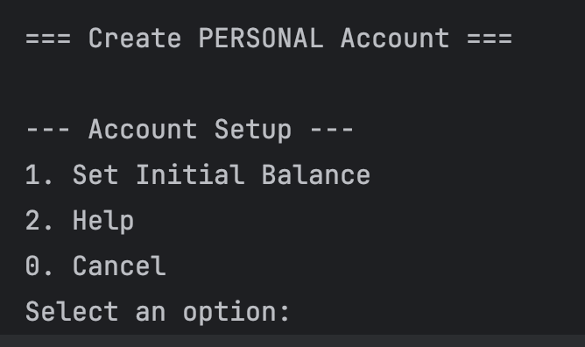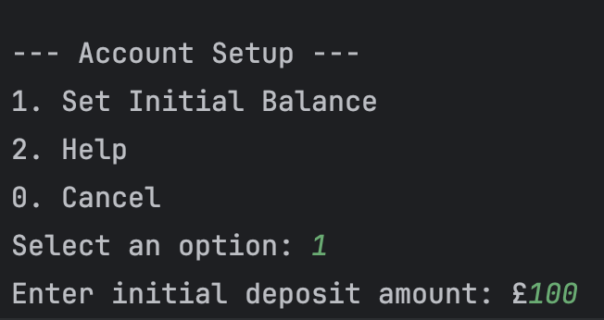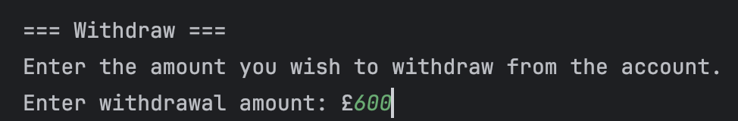

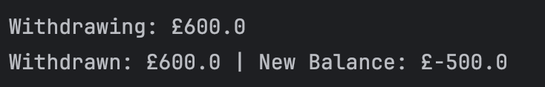

Test number 2

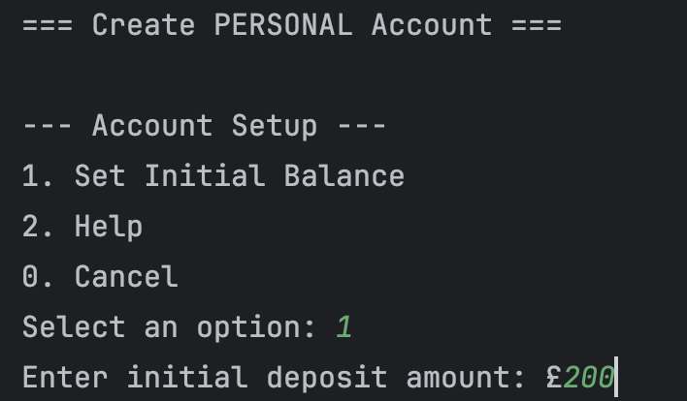
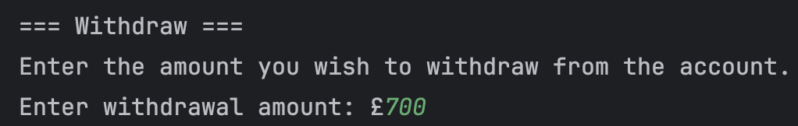

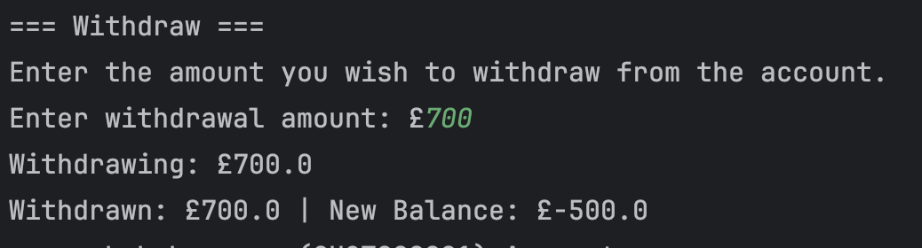

Test number 3

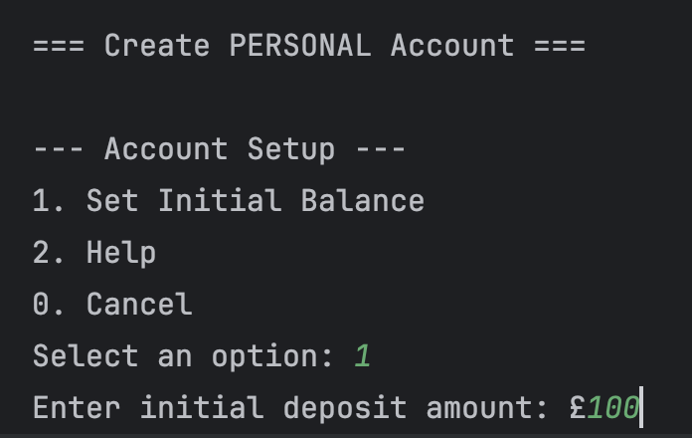

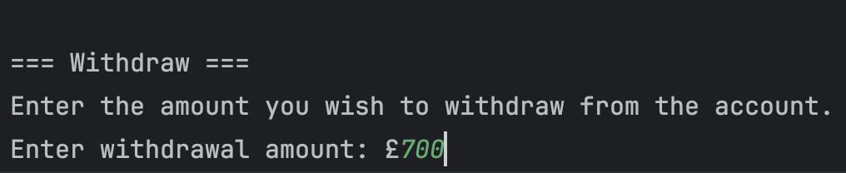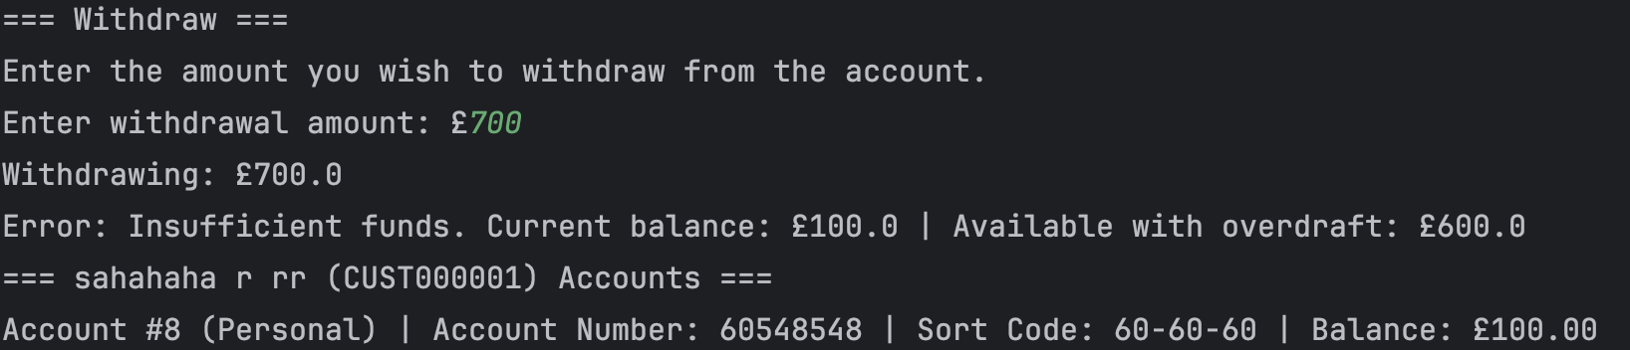

Test number 4

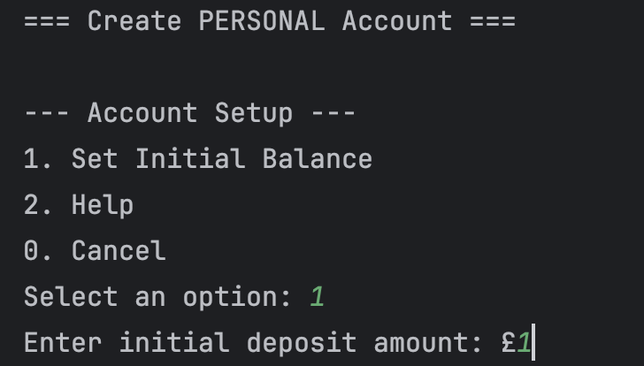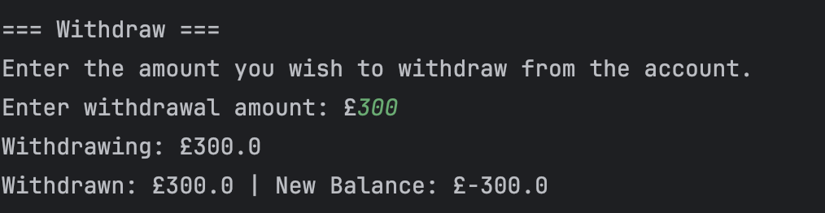

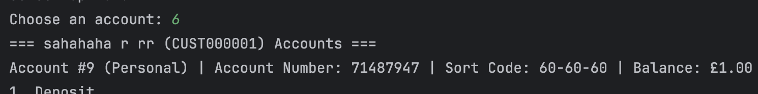

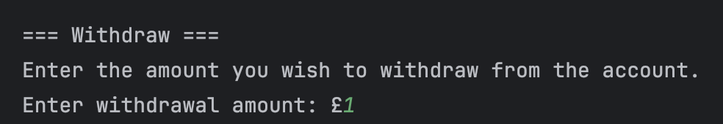

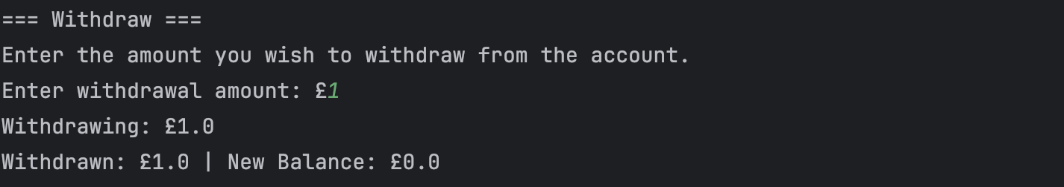

Test number 5

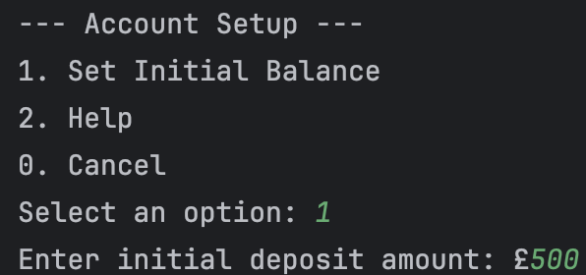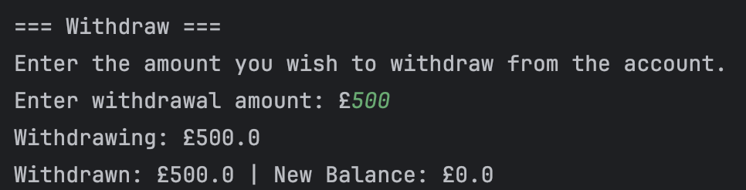

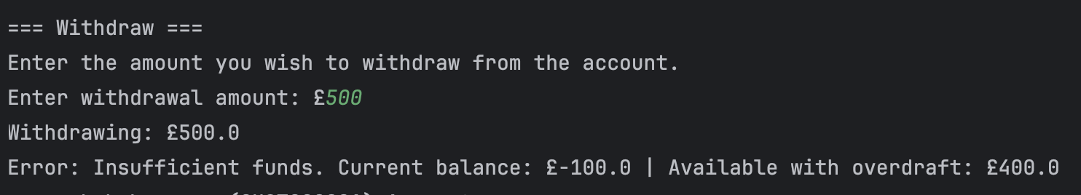

Test number 6

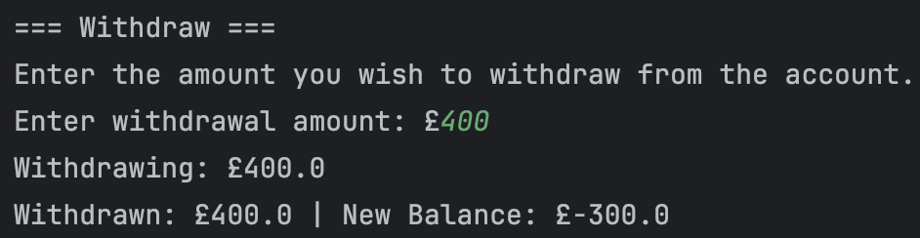

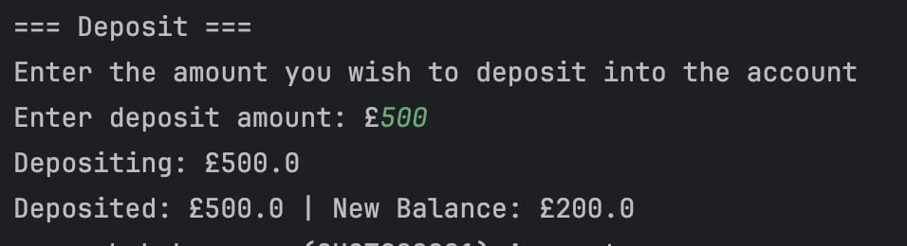

Test number 7

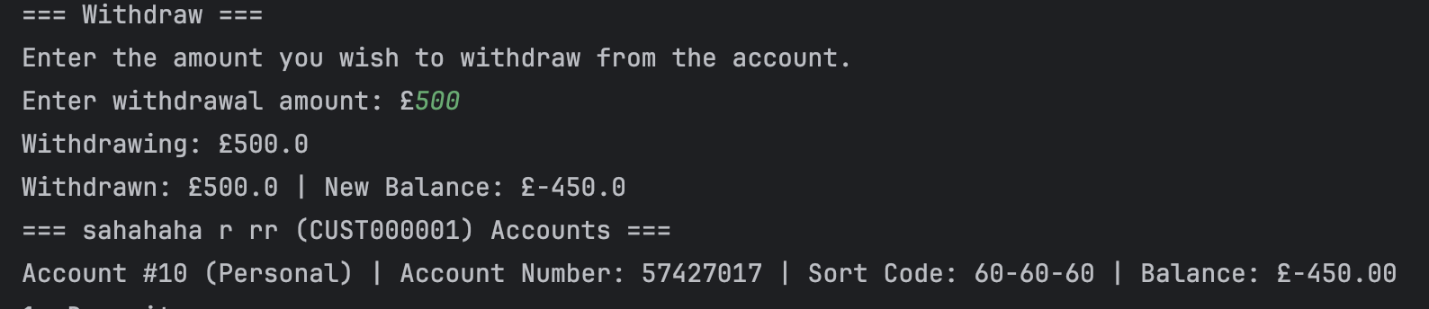

Test number 8

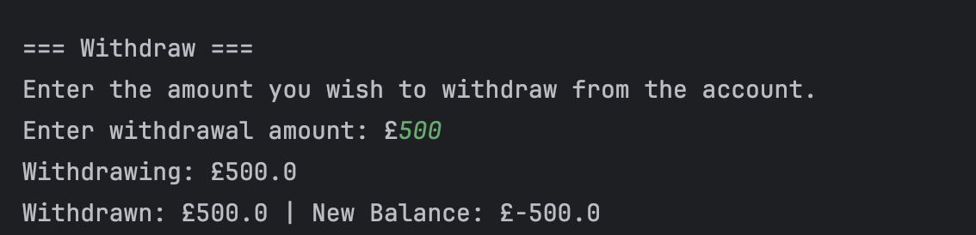

Invalid characters when depositing or withdrawing

Test Number | Test Case Type | Description | Test Steps | Test Data | Expected Results | Actual Results | Status  (Pass/Fail)
1 | Input Validation | Text characters for deposit | 1. Select deposit option2. Enter "abc" as amount | Input “abc” | Error: "Invalid  amount entered.  Please enter a  numeric value." | Error: "Invalid amount entered. Please enter a numeric value." | Pass
2 | Input Validation | Special characters for withdrawal | 1. Select withdrawal option2.  Enter "!@#$%" as amount | Input: "!@#$%" | Error: "Invalid  amount entered.  Please enter a  numeric value." | Error:  "Invalid  amount  entered.  Please  enter a  numeric  value." | Pass
3 | Input Validation | Mixed  alphanumeric  for deposit | 1. Select deposit option  2.Enter "abc123" as amount | Input: "abc123" | Error: "Invalid amount entered. Please enter a numeric value." | Error: "Invalid amount entered. Please enter a numeric value." | Pass
4 | Input Validation | Zero value for deposit | 1. Select deposit option  2. Enter "0" as amount | Input: "0" | Error: "Deposit  amount must be  greater than  zero!" | Error:  "Deposit  amount must  be greater  than zero!" | Pass
5 | Input Validation | Large number for deposit | 1. Select deposit option2. Enter  "999999999999999999.99" | Input: "999999999999999999.99" | Should be  rejected or  limited | Amount accepted (no limits) | Fail
6 | Input Validation | Scientific  notation | 1. Enter "1e5" | Input: "1e5" | Should be  rejected or  parsed as  100000 | Error: "Invalid  amount  entered" | Fail
7 | Input Validation | Comma separators | 1. Enter "1,000.50" | Input: "1,000.50" | Should parse as 1000.50 or reject | Error: "Invalid amount entered" | Pass
8 | Input Validation | SQL injection attempt | Enter: "DROP TABLE accounts" | Input SQL injection attempt | Should be sanitized/rejected | Error: "Invalid amount entered" | Pass

Test number 1

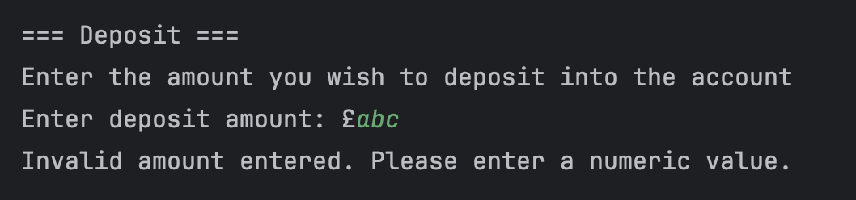

Test number 2

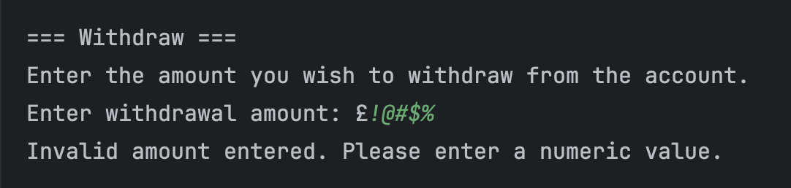

Test number 3

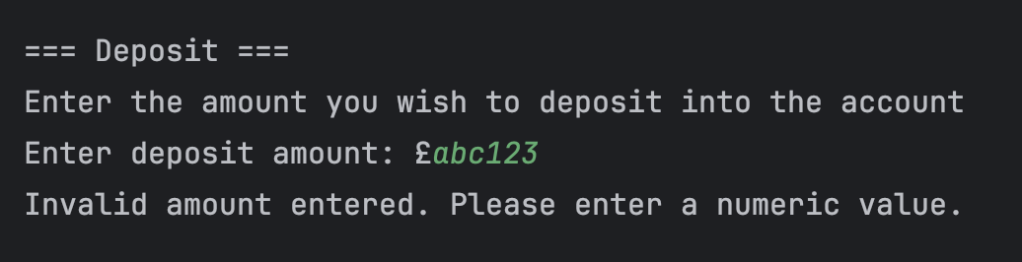

Test number 4

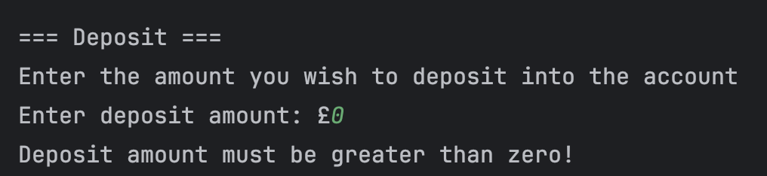

Test number 5

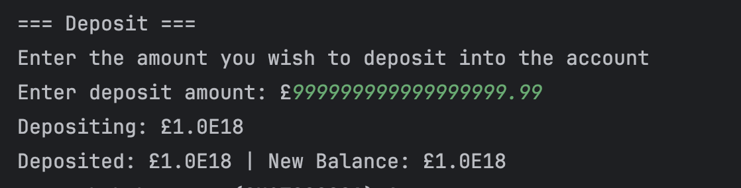

Test number 6

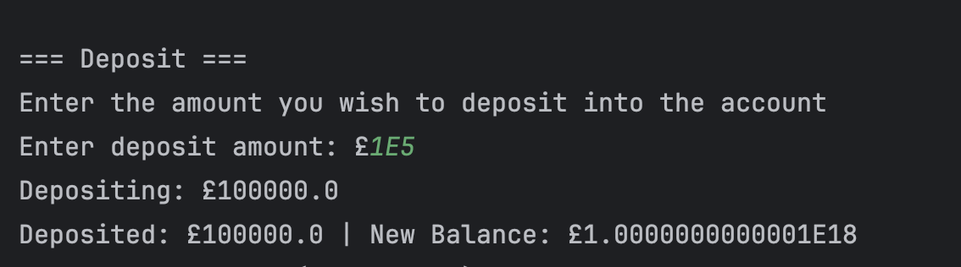

Test number 7

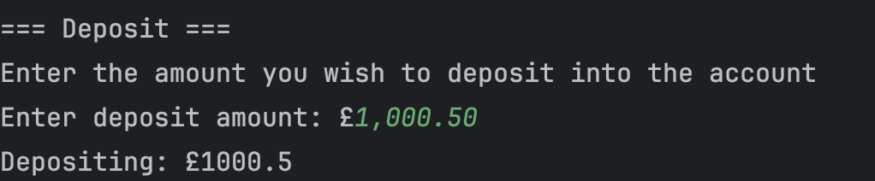

Test number 8

